APPENDIX

A : STEPS FOR PROGRAMMING:

1 : Open vivado

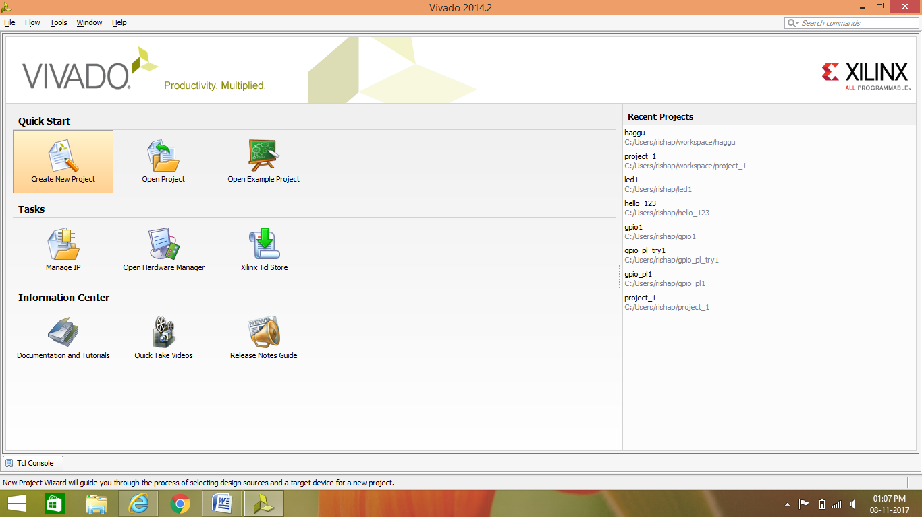

2 : Create new project:

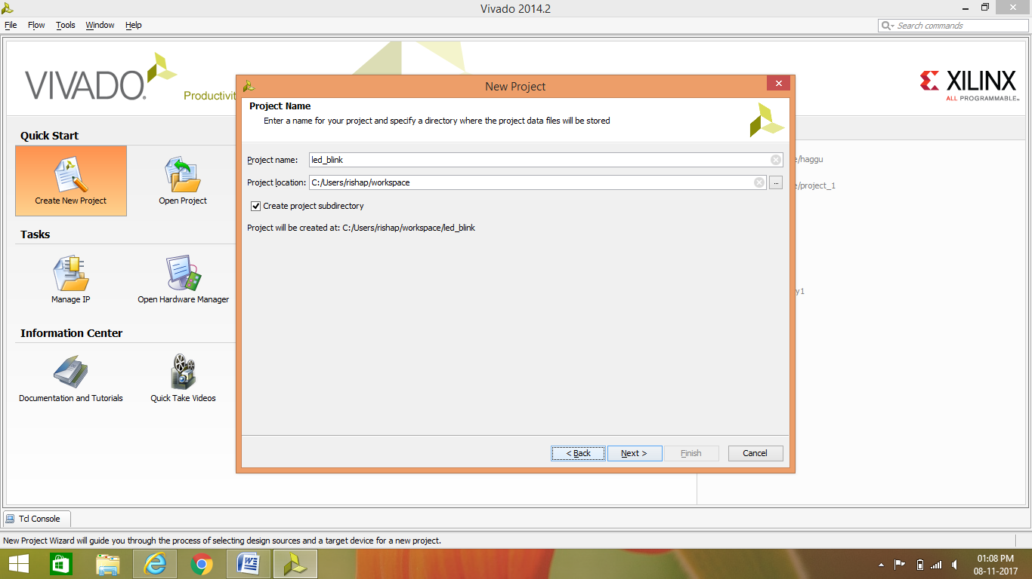

3 : Select RTL project

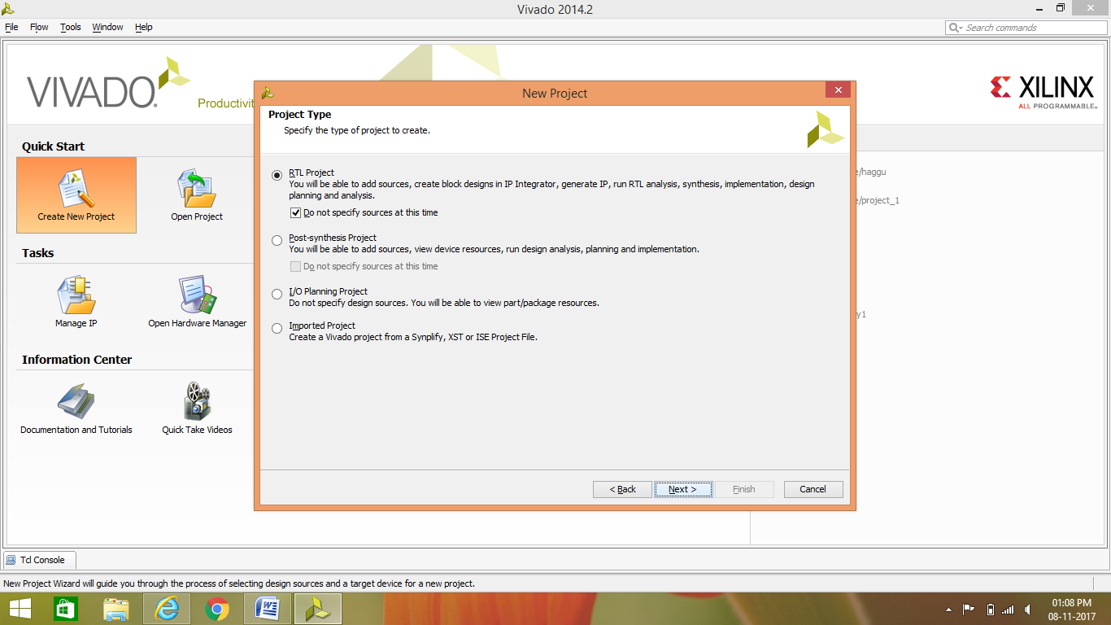

4 : Select which board/part is to be programmed:

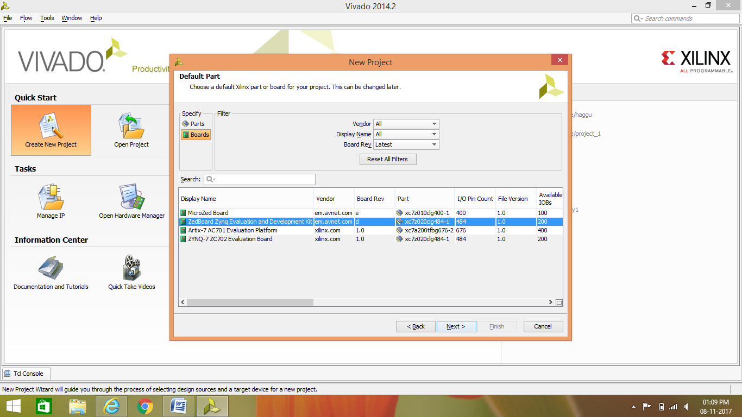

5 : Create a new block designed and name it.

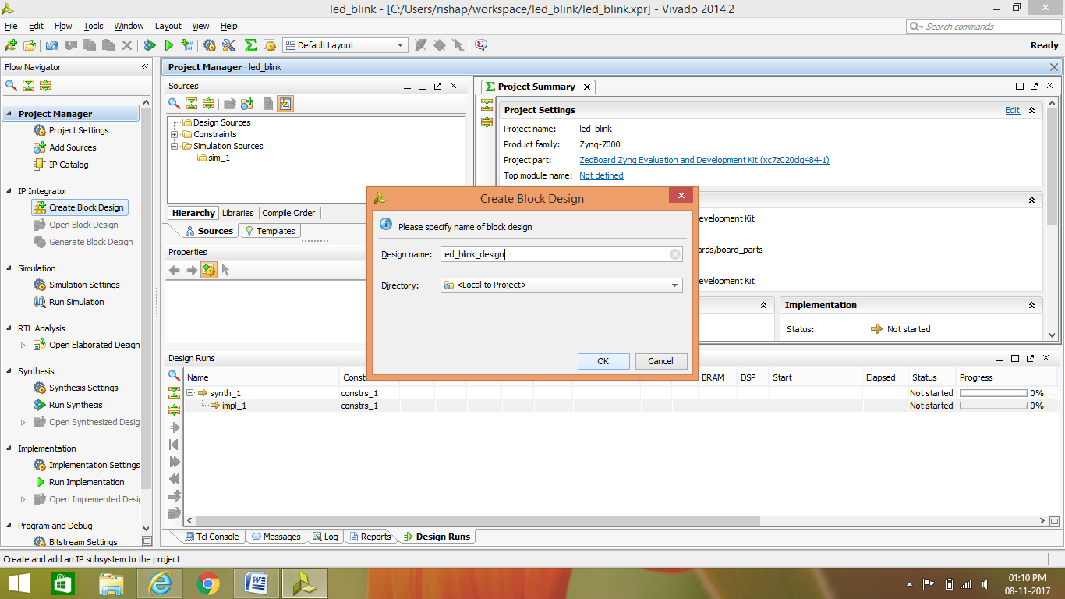

6 : Select add IP to Add ZYNQ processor

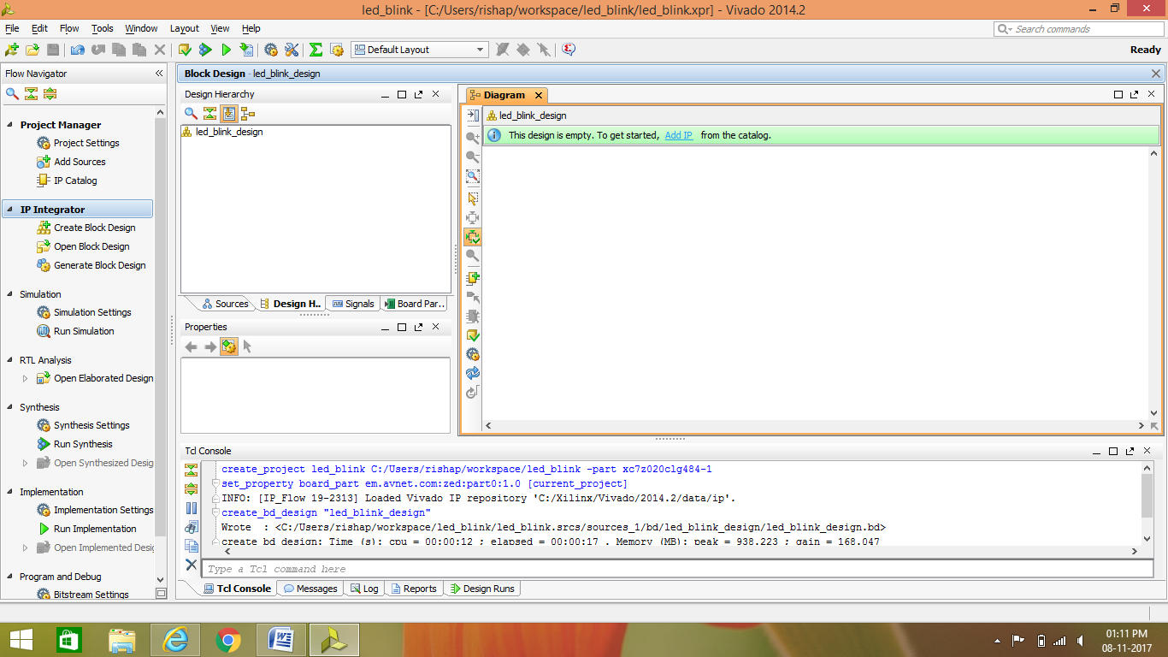

7 : Add ZYNQ processor

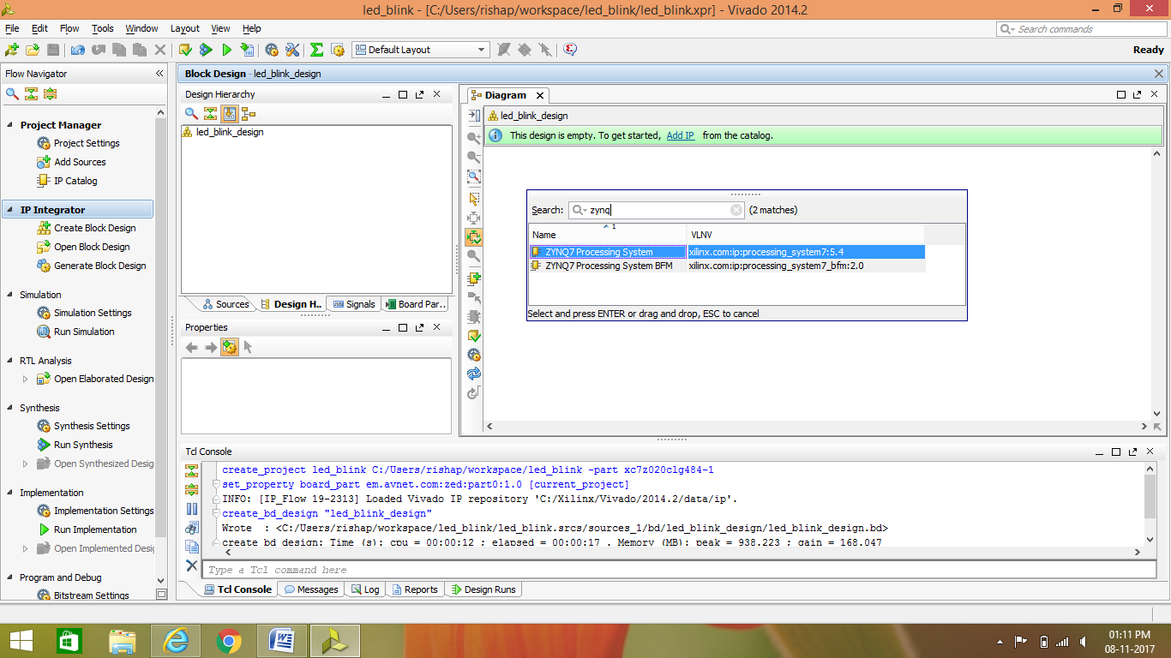

8 : double click on the ZYNQ block to open its properties:

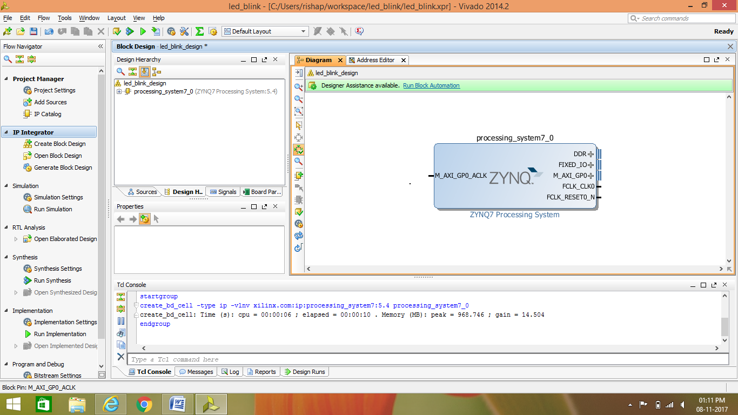

9 : configure the ZYNQ block according to need:

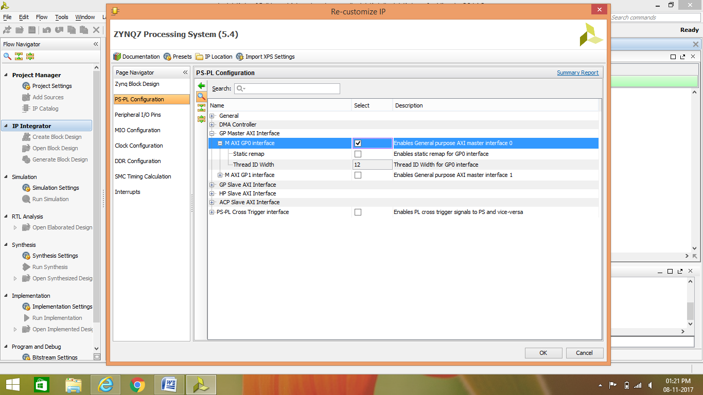

10 : Add other IP core as per need :

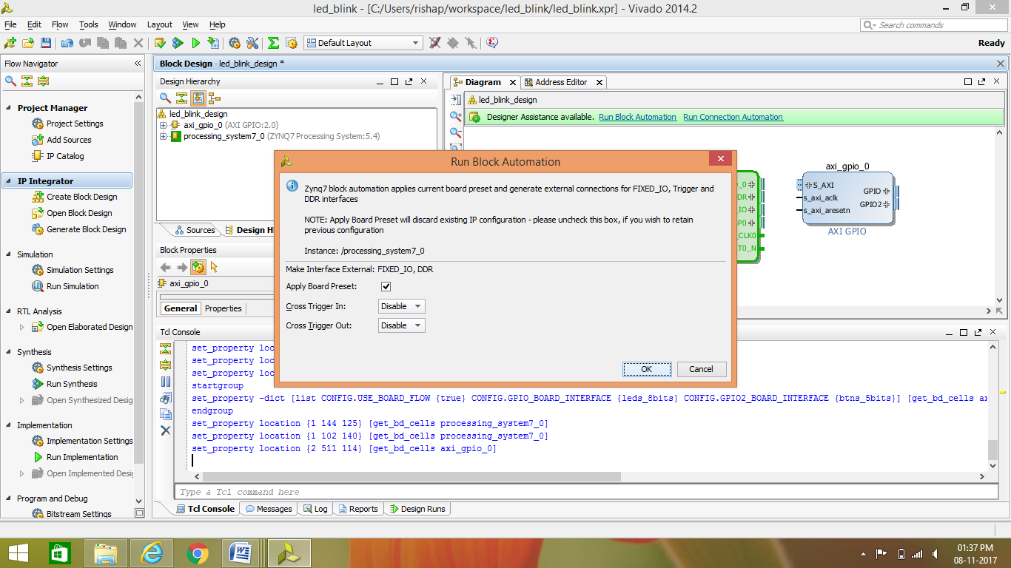

11 : use Run connection automation to connect your hardware:

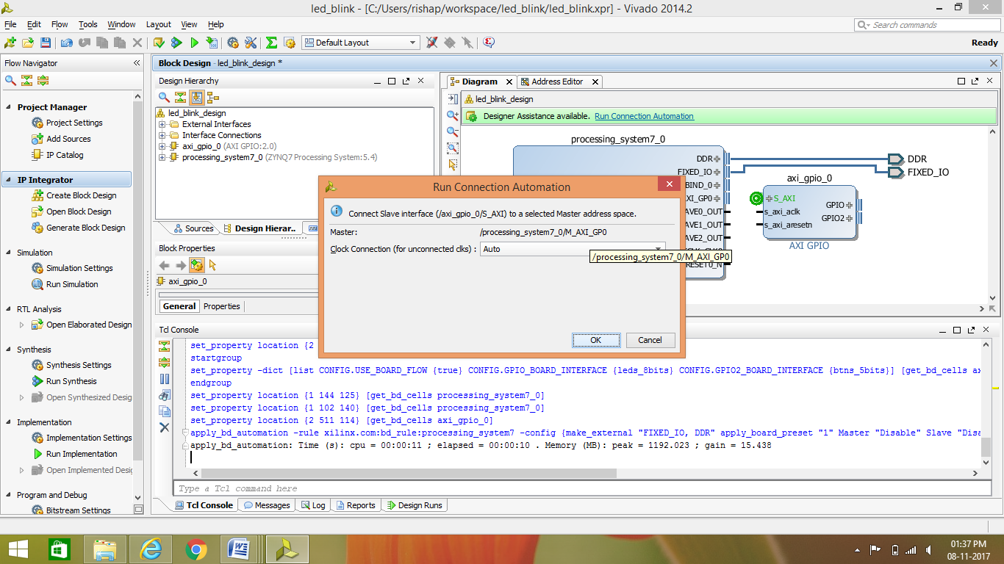

12 : finally your hardware block will be created then ,Right click on your design under Design sources

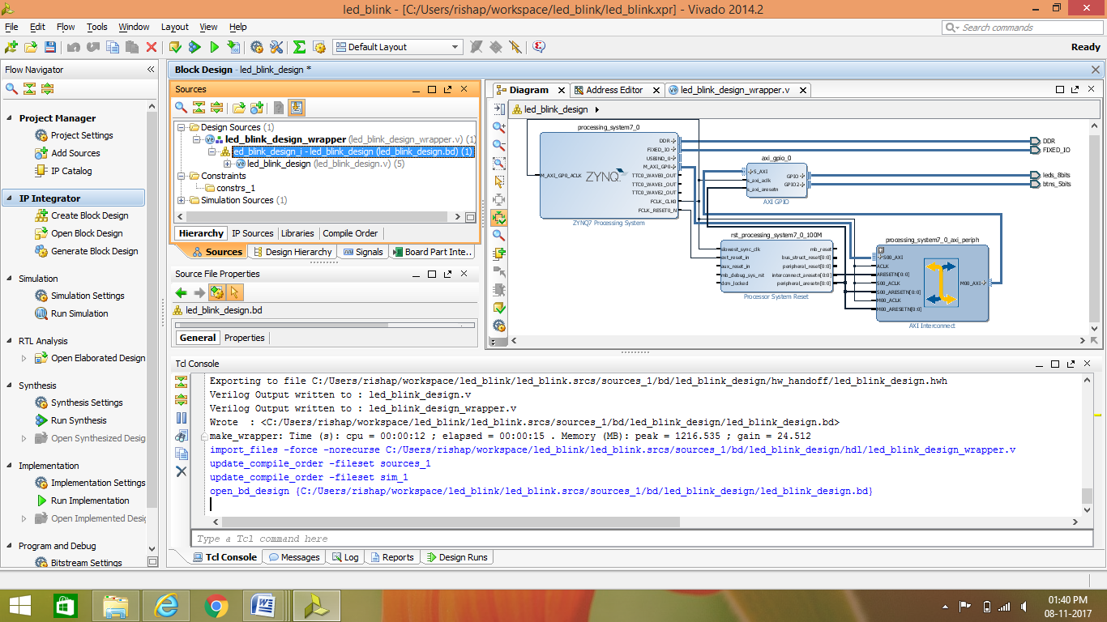

13 : select create HDL Wrapper to have a verilog file of the hardware

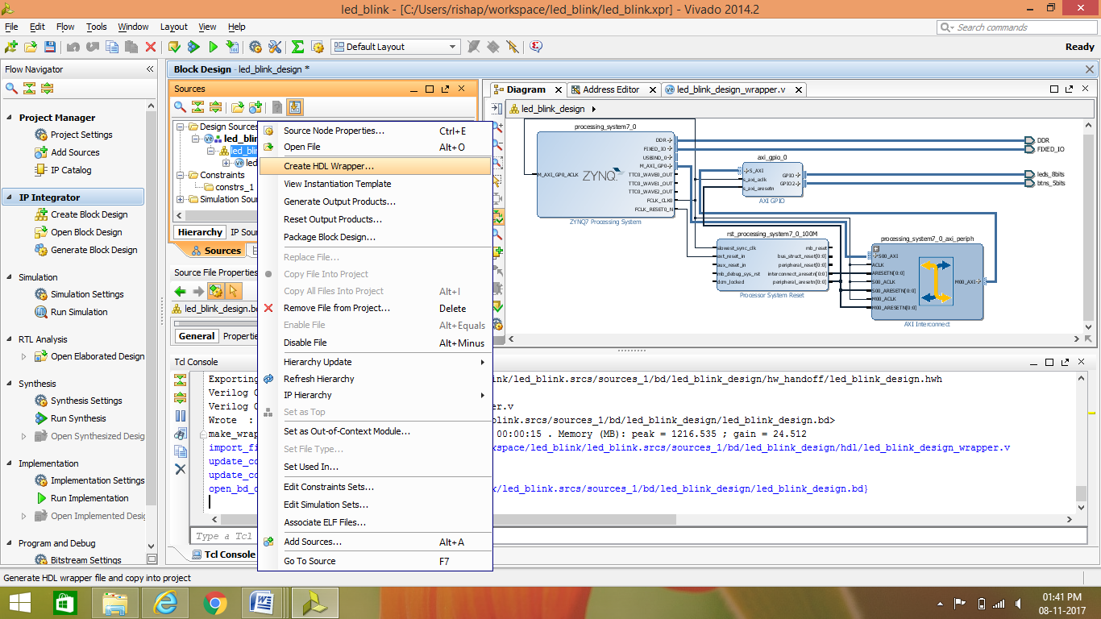

14 : Verilog code for configuring FPGA can be added if required, to the verilog code generated & then Select create ‘generate output products‘

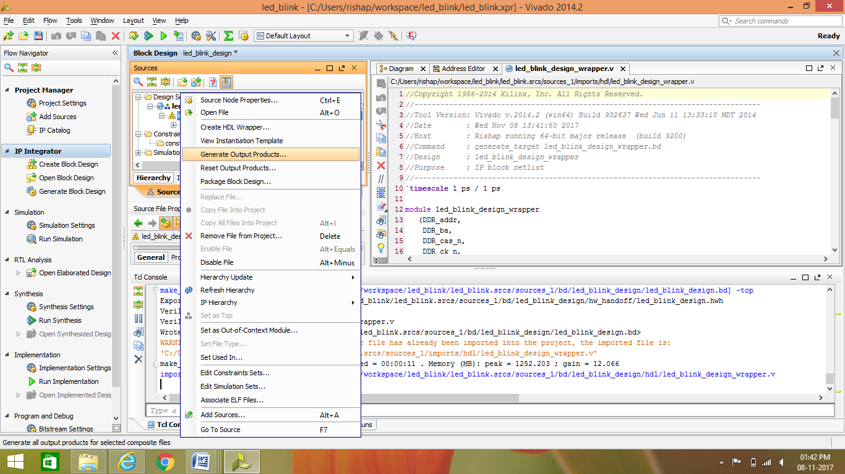

15 : click on’ generate bitstream’ to obtain bitstream file for programming FPGA 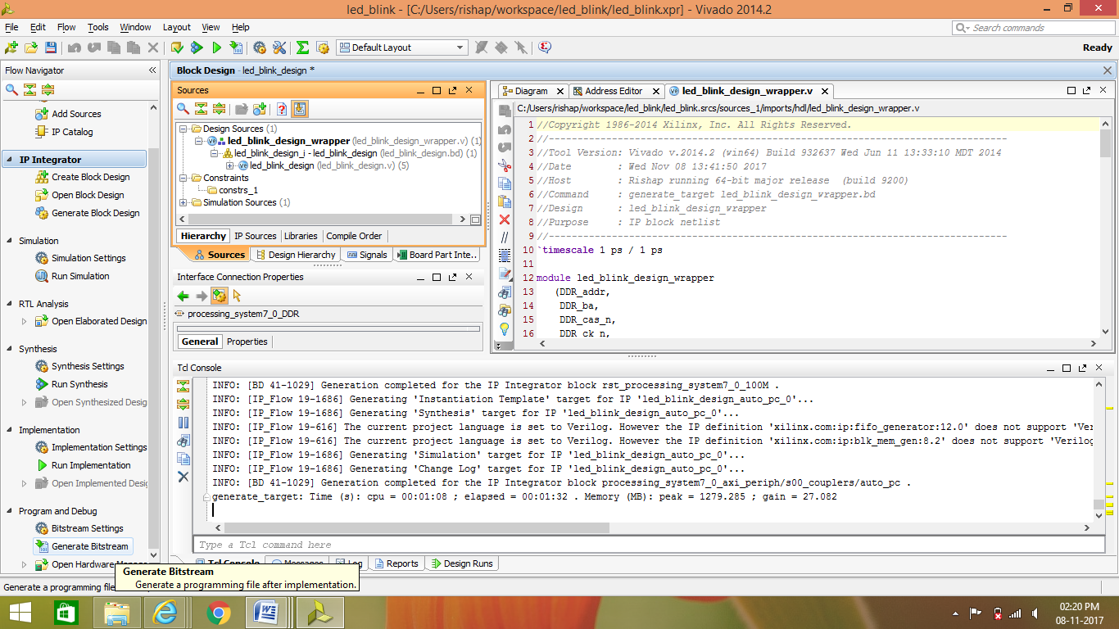

16 : After bitstream generation ,it should show a dialog box below and select “ Open Implement Design” to do floor planning,I/O planning,clock planning and timing Analysis.

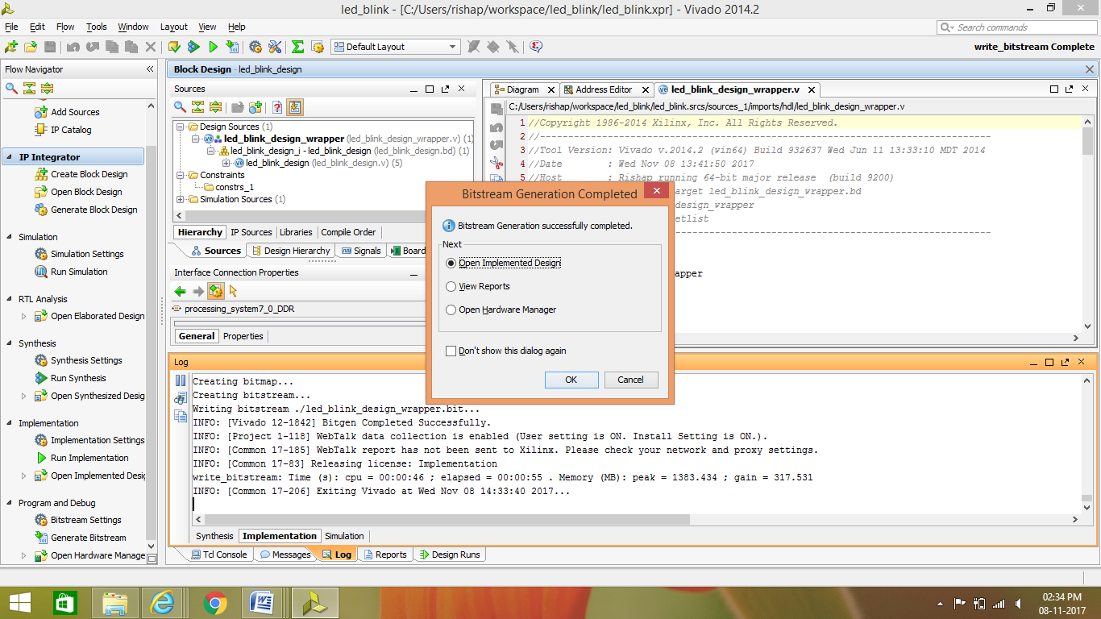

17 : click on file -> export -> export hardware

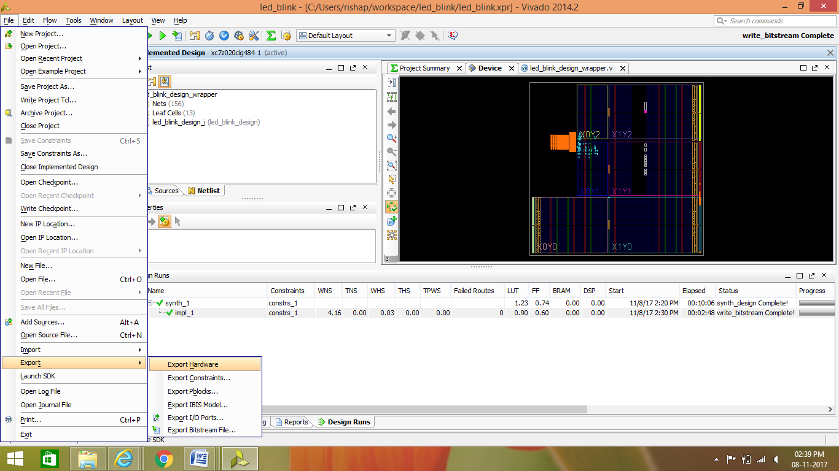

18 : Check the include bitstream

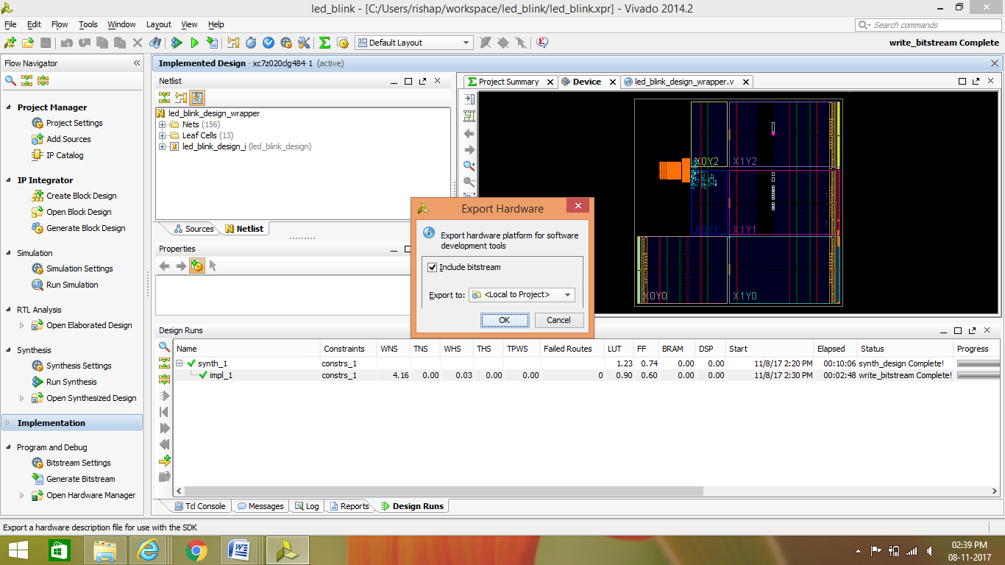

19 : click on file -> export -> export hardware

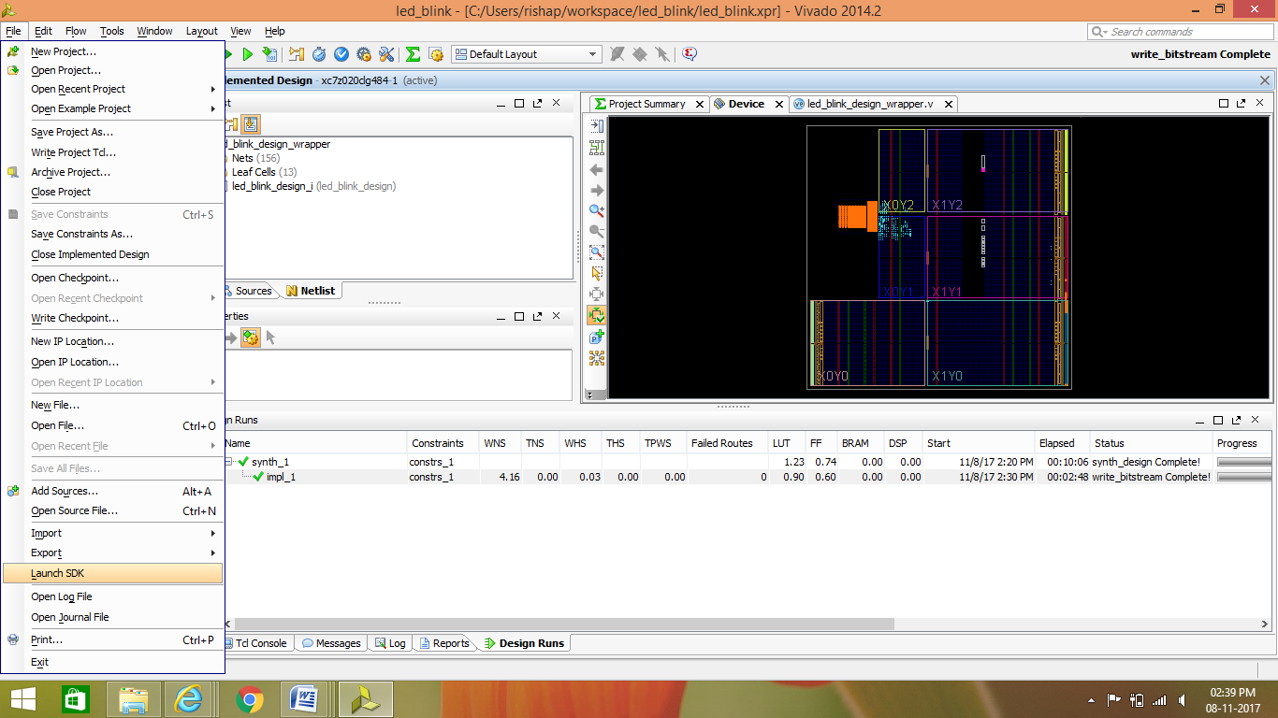

20 : Click OK to launch SDK

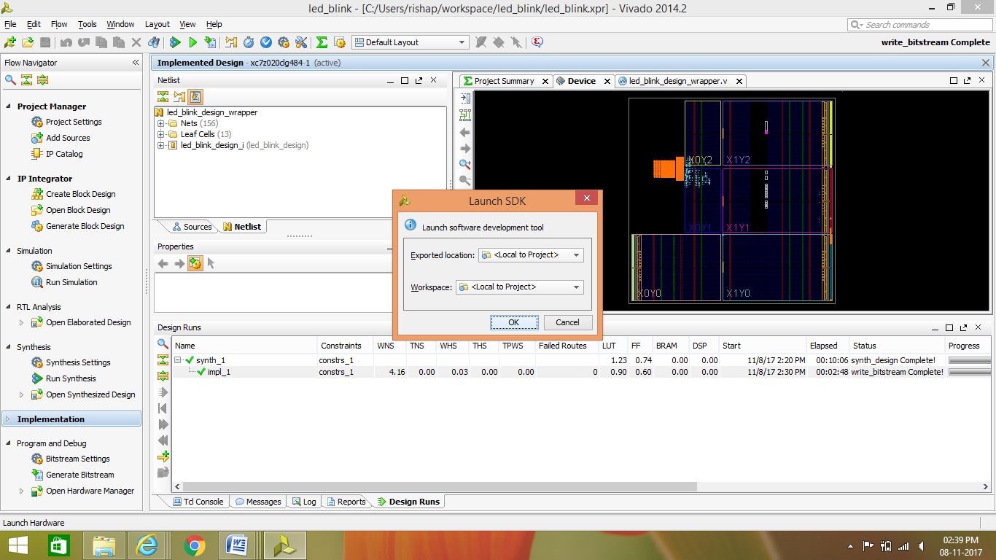

21 : After launching it will show the hardware platform specification which was exported from Vivado

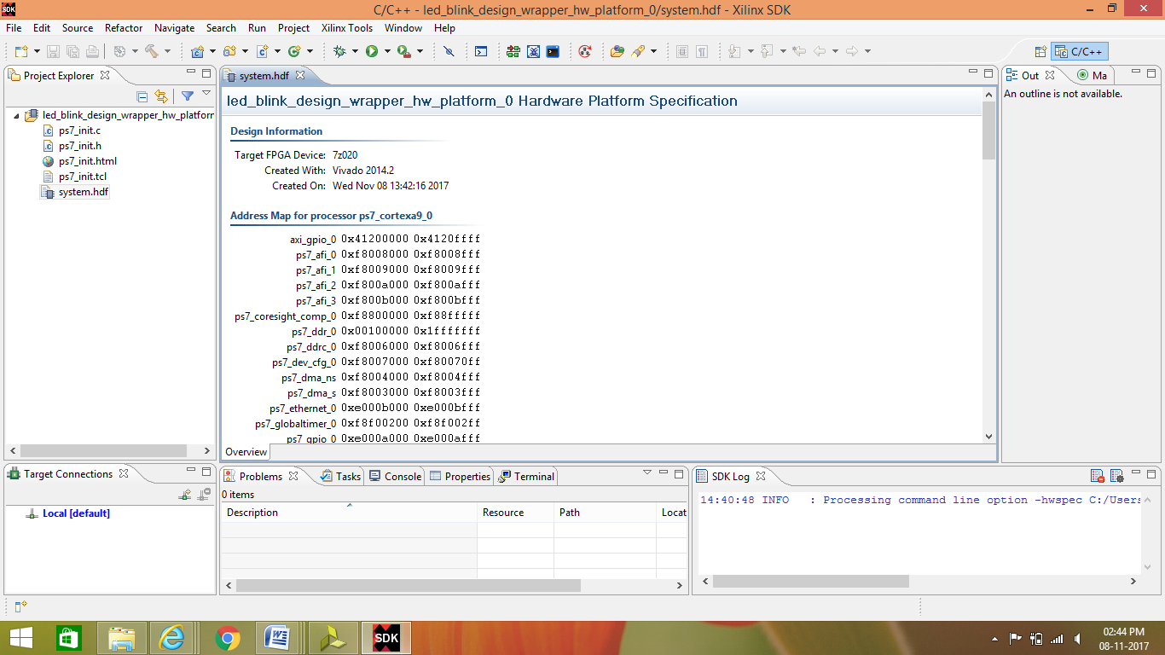

22 : Click on file -> new -> select application project

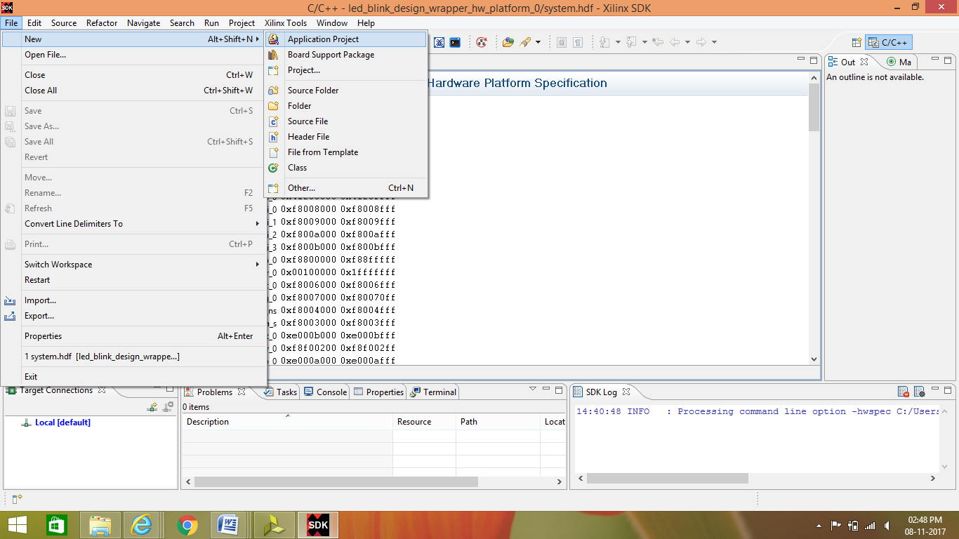

23 : type project name -> check create new bsp and select option shown below and click finish:

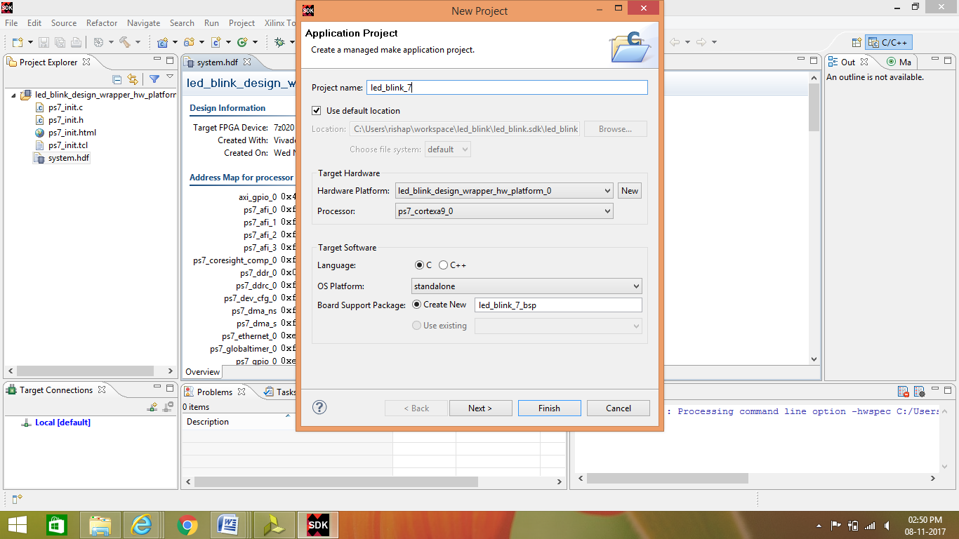

24 : Create ‘C’ source file from ->project dialog box at the left window in src folder

And type code in that file,

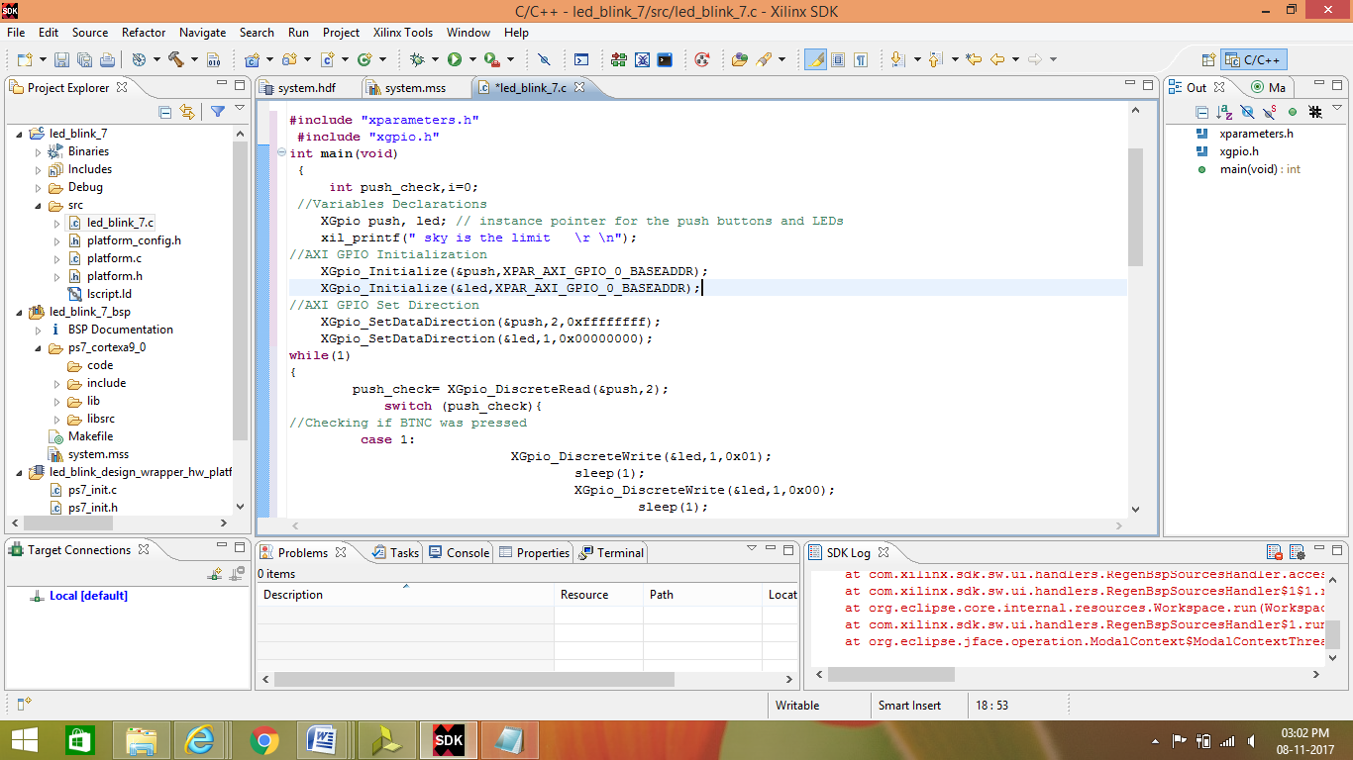

25 : click on -> file -> Save All

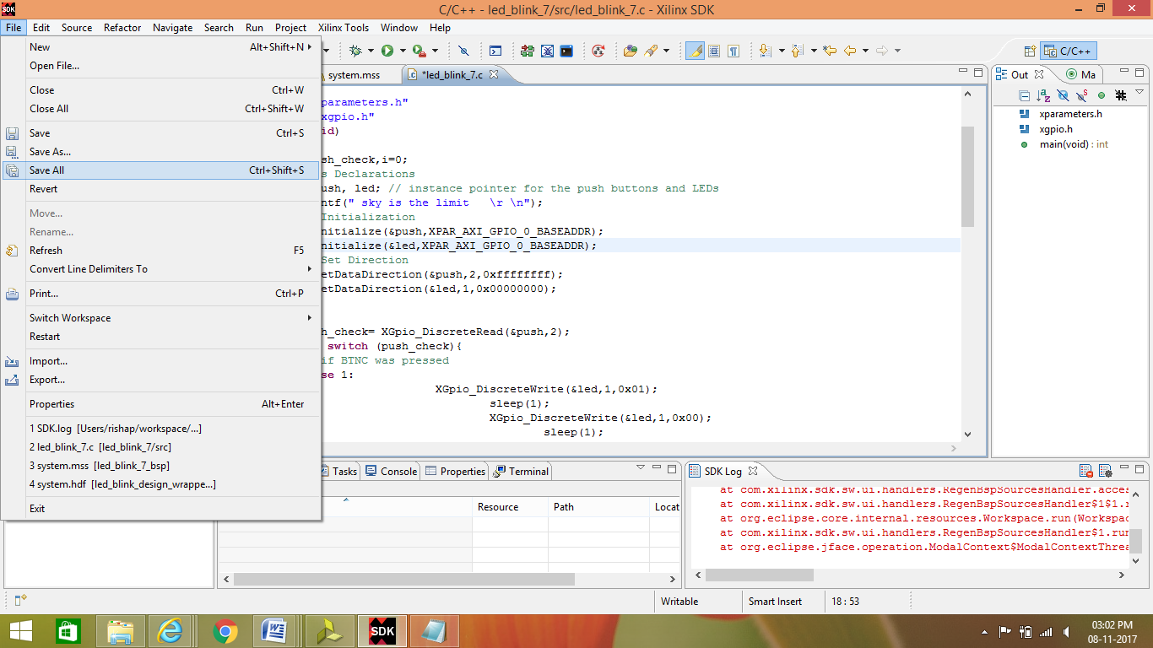

26 : Build the project by clicking on hammer sign

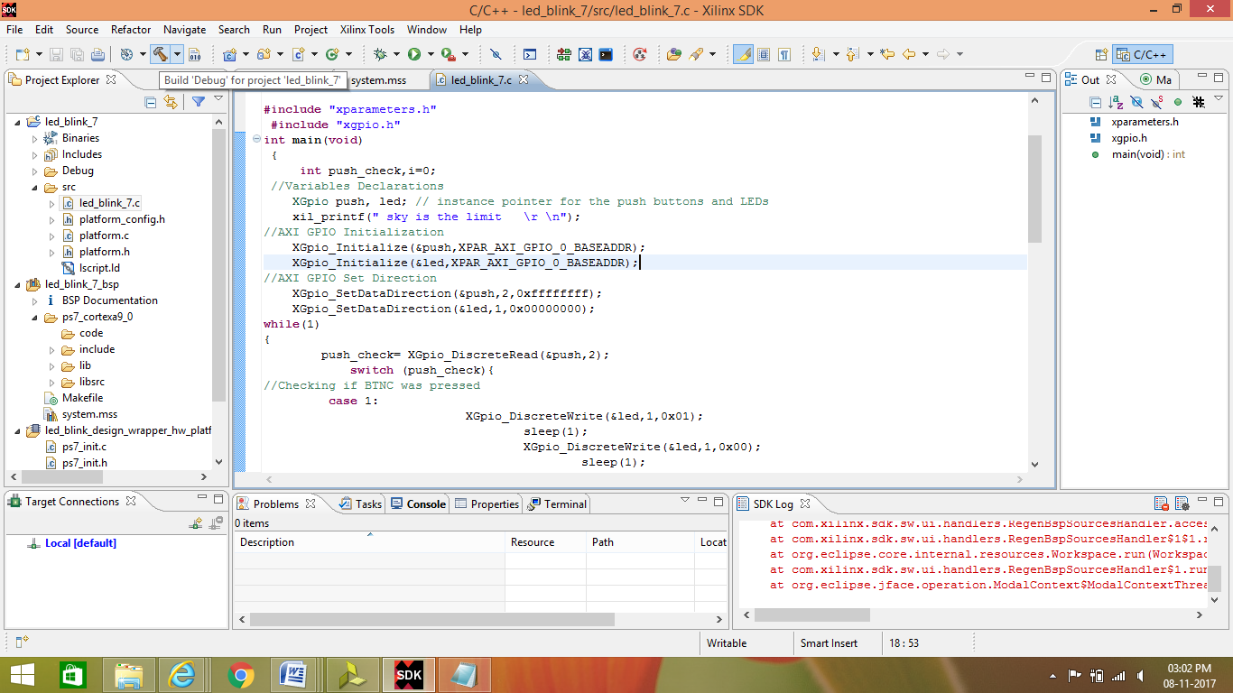

27 : click on -> Xilinx Tools -> select program FPGA

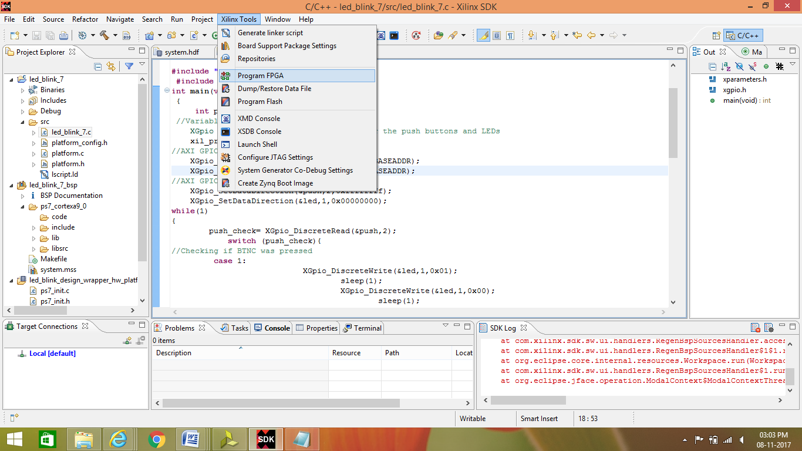

28 : select the bit file and then program:: it is use to program the FPGA part in the ZYNQ processor

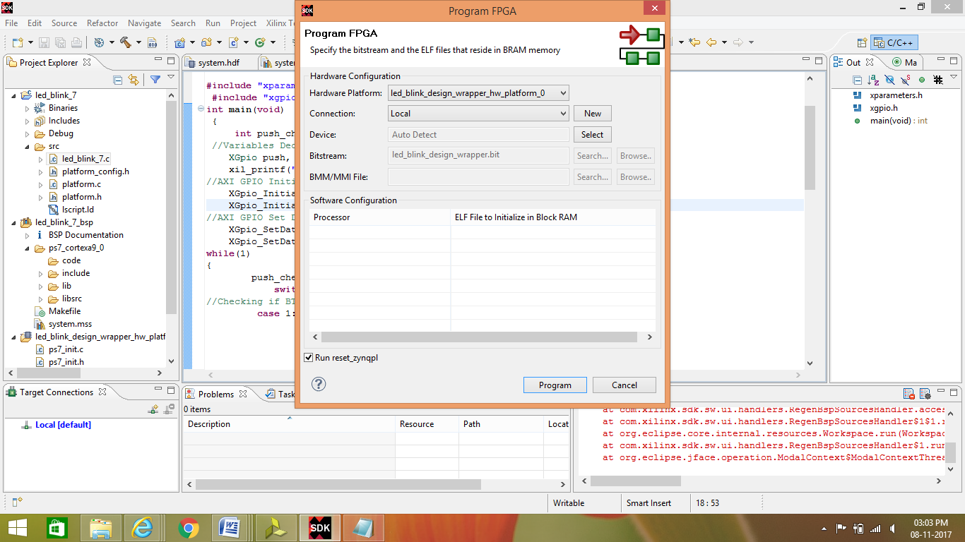

29 : To program the ARM in ZYNQ :: Right click on -> project created name -> Run As -> Launch on Hardware(GDB) .

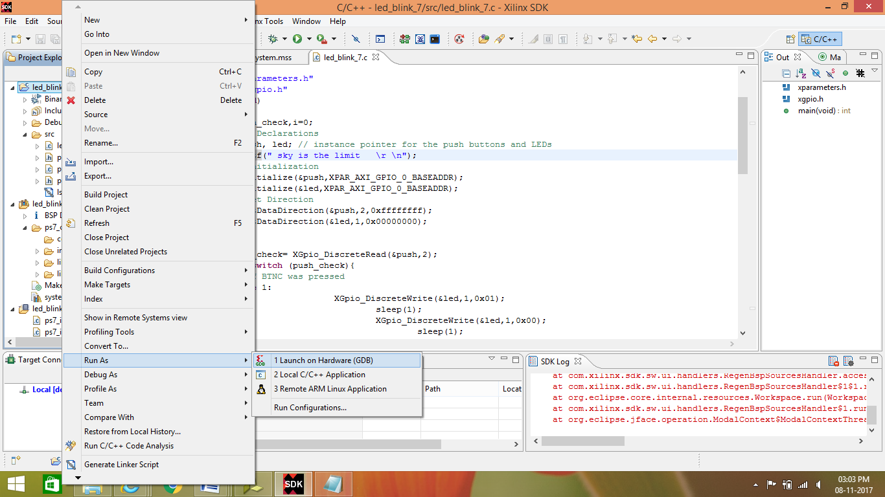

30 : Connect the Zedboard with the PC with the USB to JTAG cable to load the program .